INSTANCE SECURITY

By Muhammad Sohail

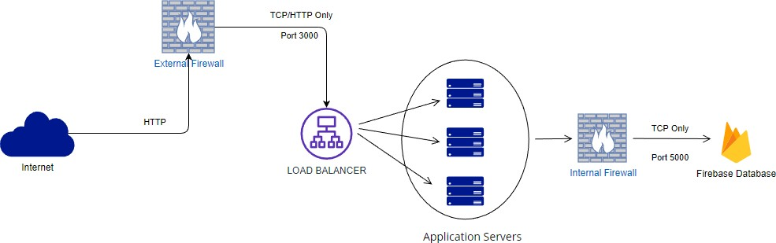

Application Servers IPs: Administrator IP:

192.168.1.29 12.34.56.78

192.168.1.30

192.168.1.31

Firewalls: Ports:

External Firewall 3000 = HTTP

Internal Firewall 22 = SSH

5000 = FIREBASE

Firewall Rules:

External Firewall Rules

|  |  |
| --- | --- |
| **Rule** | **Description** |
| permit tcp any LoadBalancer 3000 | Only TCP connection is allowed through port 3000 which is http port. |
| permit ip any LoadBalancer 3000 | Any IP can make a request to the LoadBalancer server through port 3000 which is http port. |
| permit tcp 12.34.56.78 22 Application-Servers | Only Administrator IP can connect to application servers through port 22 which is an SSH port for server management. |

Internal Firewall Rules

|  |  |
| --- | --- |
| **Rule** | **Description** |
| permit tcp 192.168.1.29  FIREBASE-DATABASE 5000  permit tcp 192.168.1.30 | Only Application Servers can request and connect with the database server using port 5000. |
| FIREBASE-DATABASE 5000 |  |
| permit tcp 192.168.1.31 |  |
| FIREBASE-DATABASE 5000 |  |
| permit group root | Only the Root and Firebase User |
| FIREBASE-DATABASE 5000 | group can access database data through port 5000. |
| permit group FIREBASE |  |
| FIREBASE-DATABASE 5000 |  |